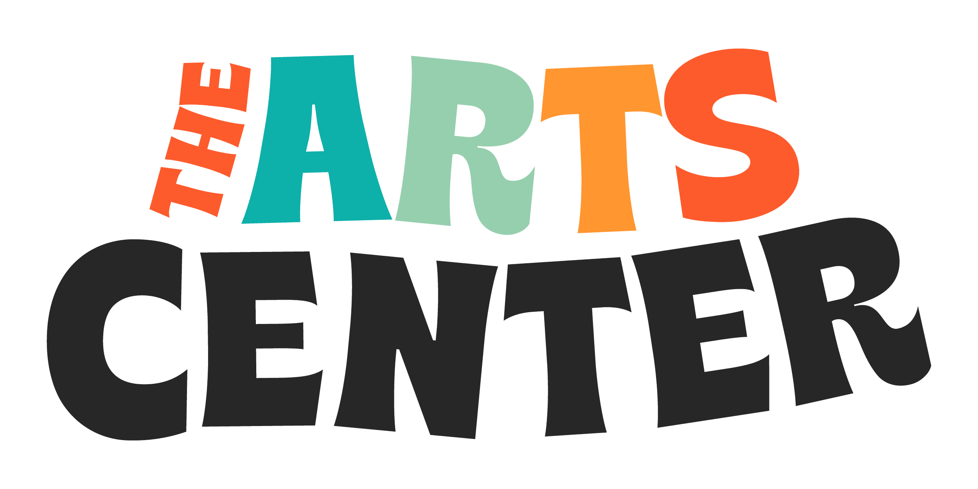

**Application: College Seat on The ArtsCenter**

**Board of Directors**

We are excited to invite applications from undergraduate and graduate students interested in serving for one academic year on The ArtsCenter Board of Directors.

For students, these special positions will provide significant, unique opportunities including professional growth, leadership experience, and networking opportunities. For The ArtsCenter, college students will bring fresh perspectives, diverse experiences, and emerging leadership into our work.

**Position Overview**

* **Term Length:** 1 year, starting in the fall semester. **Commitment:** Approximately 5-10 hours per month, including regular on-site board meetings, committee work, and organizational events.
* **Eligibility:** Current college students (undergraduate or graduate) who demonstrate an interest in community participation, leadership, the arts, and education.
* **Support:** Students will receive mentoring and onboarding to ensure a meaningful and successful board experience.

